**Motorcycle Proximity Sensor**

**System Design and Modeling**

Rev. 1.0 11/14/14

Rusty Wiseman

Dan Frister

Noah Erickson

Branden Driver

**System - Level 0 Block Diagram**

**[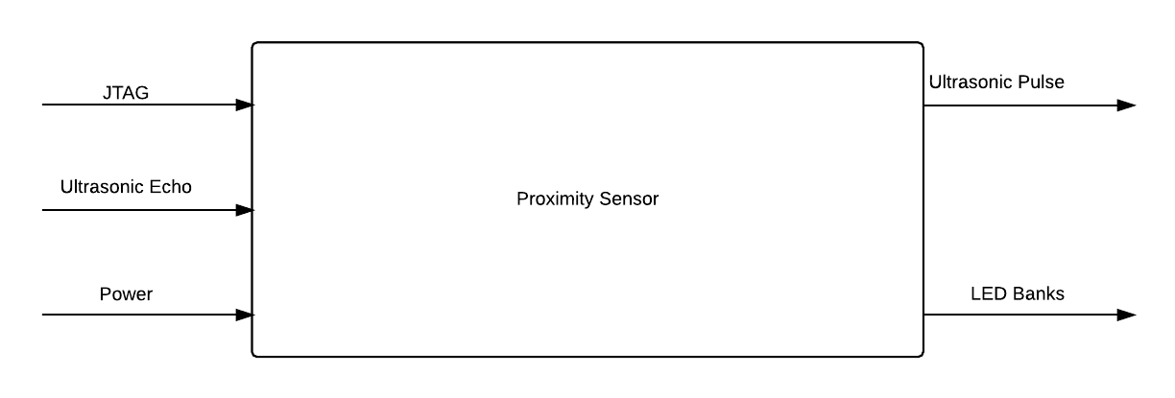](https://www.lucidchart.com/documents/edit/2127a300-9fd5-4640-a088-d50122462c29/0?callback=close&v=733&s=612)**

|  |  |
| --- | --- |
| **Module** | **Proximity Sensor** |
| **Inputs** | * Power: 12VDC from motorcycle battery * Ultrasonic Echo: Return echo from ultrasonic ranging output. |
| **Outputs** | * Ultrasonic Pulse: Each sensor emits eight 40kHz pulses when triggered. * LED Banks: Lights up LED arrays based on which sensor is being polled. |
| **Functionality** | Proximity sensor uses ultrasonic pulses to detect cars behind the vehicle and to the sides in the rider’s blind spots. The display lights up LEDs banks corresponding to which sensor detects the object. Each bank contains three LEDs that light up based on distance object is from sensor. |

**System – Level 1 Diagram**

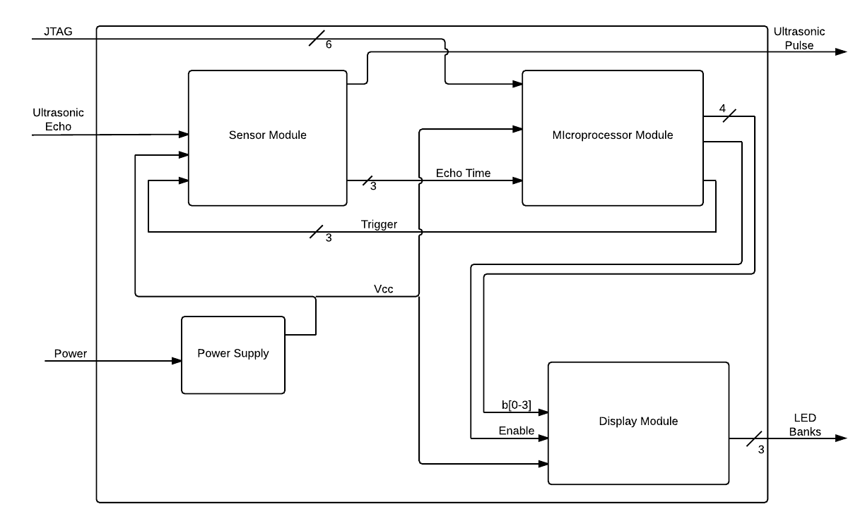

|  |  |
| --- | --- |
| **Module** | **Sensor Board** |
| **Inputs** | * Vcc: 5V DC Trigger: 10us 5V logic high to tell sensors to take measurement * Ultrasonic Echo: Return echo from ultrasonic ranging output. |
| **Outputs** | * Echo Time: Time elapsed between transmit and receive of ultrasonic pulse. * Ultrasonic Pulse: Each sensor emits eight 40kHz pulses when triggered. |
| **Functionality** | Receives signals from the processor to begin a measurement cycle for each sensor in turn. The sensors then emit a series of ultrasonic pulses then returns the time elapsed between transmit and receive of the reflected pulse if an object is present. |

|  |  |
| --- | --- |
| **Module** | **Microprocessor** |
| **Inputs** | * Vcc: 5V DC * Echo Time: Time elapsed between transmit and receive of ultrasonic pulse. * JTAG: Standard JTAG interface for programming ATMega328. |
| **Outputs** | * b0-b3: Binary LED identification code. Identifies which LED to light based on distance of object from sensor. * Trigger: 10us 5V logic high to tell sensors to take measurement. * Enable: Logic low signal sent to enable demux when binary ID code sent. |
| **Functionality** | Triggers and polls sensor arrays. Receives echo time from sensors and converts to distance. Sends binary data to display to light LED array corresponding to sensor and individual LED in array corresponding to distance of object detected. |

|  |  |
| --- | --- |
| **Module** | **Display Board** |
| Inputs | * Vcc: 5V DC * b0-b3: Binary LED identification code. Identifies which LED to light based on distance of object from sensor. * Enable: Logic low signal sent to enable demux when binary ID code sent. |
| Outputs | * LED Banks: Lights up LED arrays based on which sensor is being polled. |
| Functionality | Demultiplexes incoming binary ID code and lights up individual LEDs in banks. Banks correspond to the sensor being polled (ie. right, left, center) and individual LEDs correspond to distance of object from sensor. |

|  |  |
| --- | --- |
| **Module** | **Power Supply** |
| Inputs | * Power: 6-12VDC power supplied from battery pack or motorcycle battery |
| Outputs | * Vcc: 5VDC regulated output. |
| Functionality | Regulates incoming power to 5VDC to supply entire system with regulated power. |

**Mainboard State Diagram**

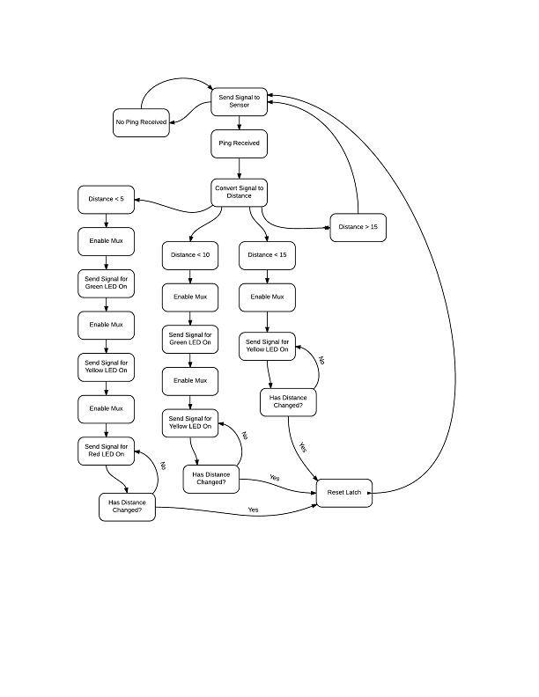

**Mainboard Interactive View**

